Semicircular-Arc Generator

Definition
# Source: AI Source: Provided by: [Data Path: Persons Table -> ID Column: 1, Name_En Column: Motasem Essam] -> From: [ChatGPT] on [7/25/2026]
A Semicircular-Arc Generator is a curved-line generator that uses a semicircular arc (exactly half of a circle) as its generating element to produce a geometric surface or solid through a prescribed movement, particularly rotation.
A semicircular arc has a central angle of ${180}^{∘}$, or $π$ radians.
Its most important generating operation is rotation about its diameter, which produces a spherical surface. When the semicircular region, rather than only its boundary arc, rotates about the diameter, it generates a solid sphere.
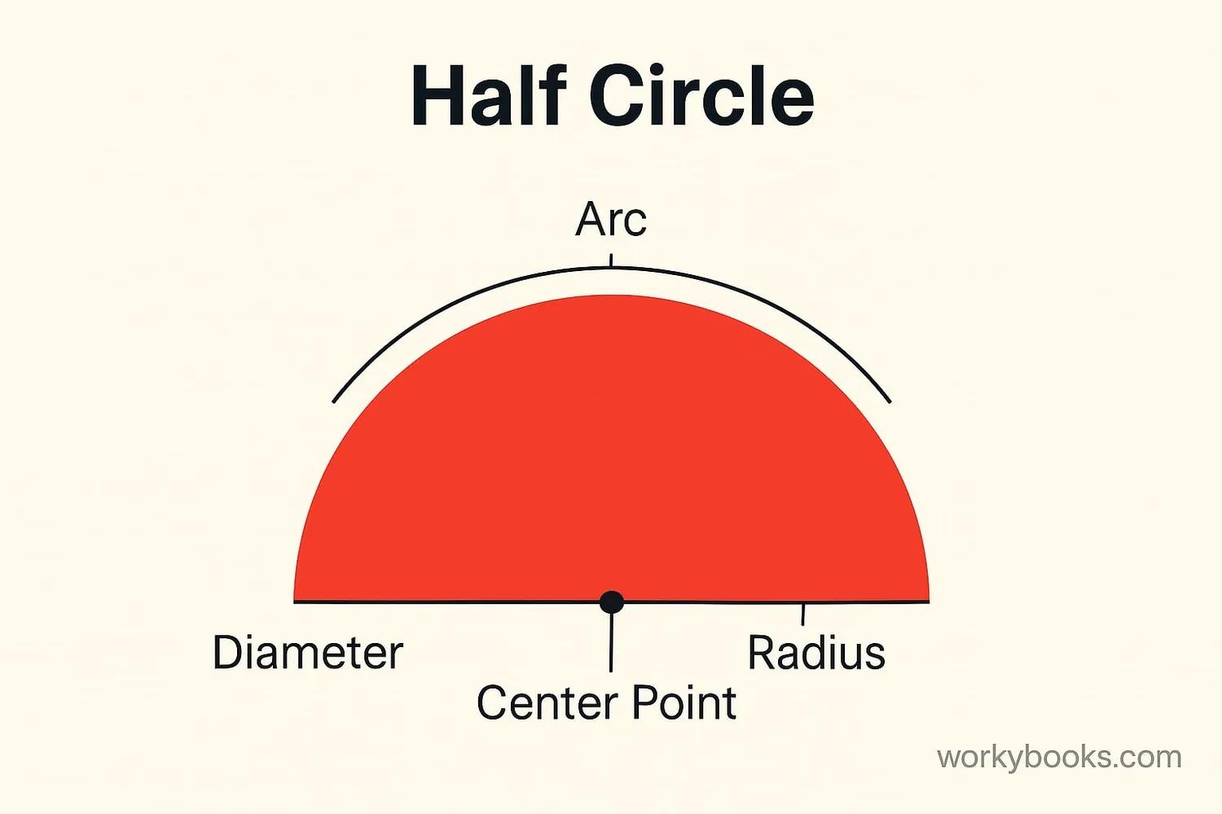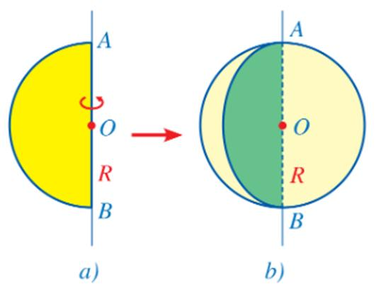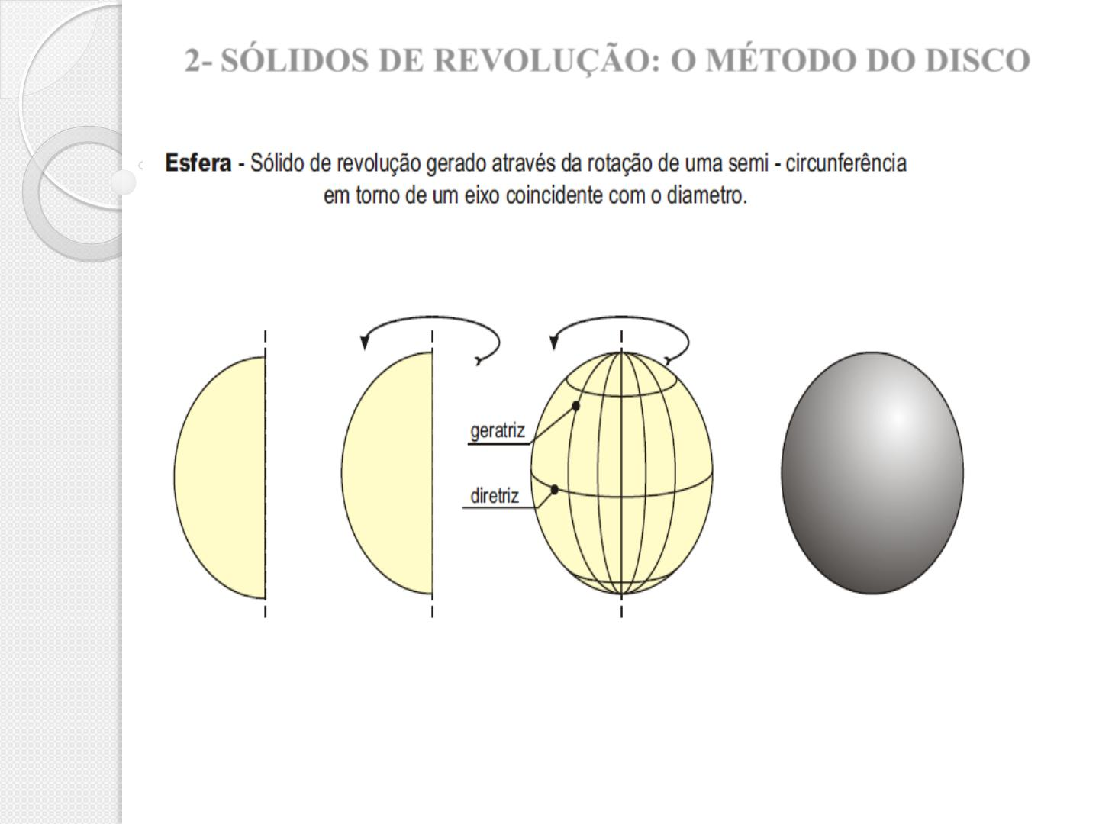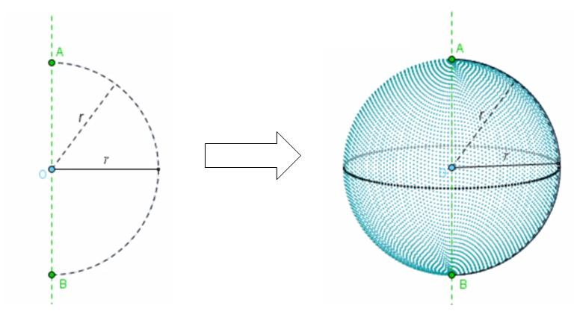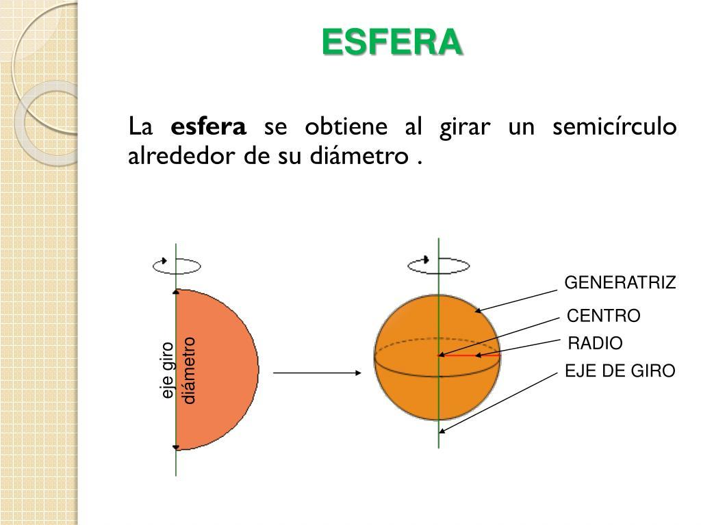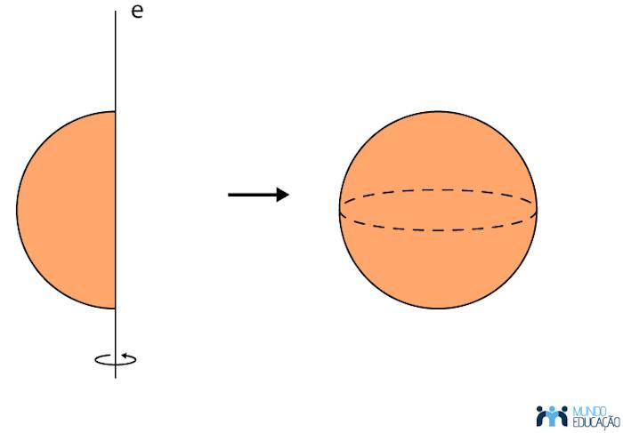

Geometric Structure
# Source: AI Source: Provided by: [Data Path: Persons Table -> ID Column: 1, Name_En Column: Motasem Essam] -> From: [ChatGPT] on [7/25/2026]
A semicircular-arc generator consists of the following elements:
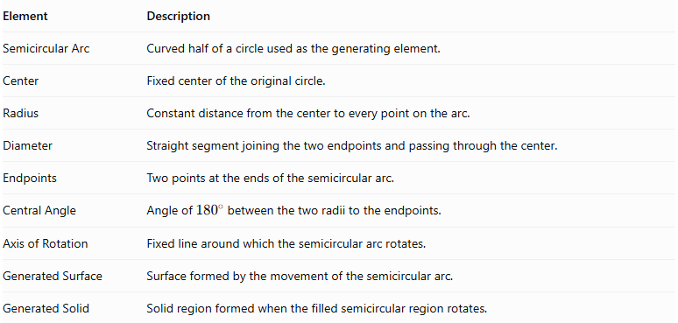
Element | Description
Semicircular Arc | Curved half of a circle used as the generating element.
Center | Fixed center of the original circle.
Radius | Constant distance from the center to every point on the arc.
Diameter | Straight segment joining the two endpoints and passing through the center.
Endpoints | Two points at the ends of the semicircular arc.
Central Angle | Angle of ${180}^{∘}$ between the two radii to the endpoints.
Axis of Rotation | Fixed line around which the semicircular arc rotates.
Generated Surface | Surface formed by the movement of the semicircular arc.
Generated Solid | Solid region formed when the filled semicircular region rotates.
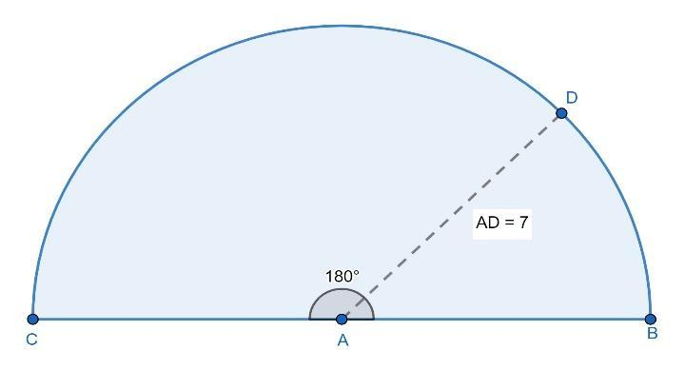

Geometric Characteristics
# Source: AI Source: Provided by: [Data Path: Persons Table -> ID Column: 1, Name_En Column: Motasem Essam] -> From: [ChatGPT] on [7/25/2026]
The semicircular arc has the following properties:
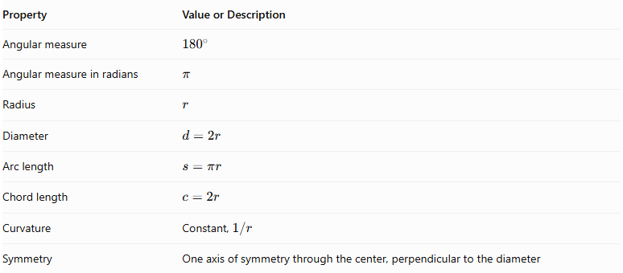
Property | Value or Description
Angular measure | $${180}^{∘}$$
Angular measure in radians | $$π$$
Radius | $$r$$
Diameter | $$d=2r$$
Arc length | $$s=πr$$
Chord length | $$c=2r$$
Curvature | Constant, $1/r$
Symmetry | One axis of symmetry through the center, perpendicular to the diameter
Arc length:
$$s=πr$$
Diameter:
$$d=2r$$
Area of the corresponding semicircular region:
$$A=\frac{1}{2}πr^{2}$$

Types According to the Axis of Rotation
# Source: AI Source: Provided by: [Data Path: Persons Table -> ID Column: 1, Name_En Column: Motasem Essam] -> From: [ChatGPT] on [7/25/2026]
The semicircular-arc generator can produce different geometric surfaces depending on the position of its rotation axis.

Rotation About the Diameter
# Source: AI Source: Provided by: [Data Path: Persons Table -> ID Column: 1, Name_En Column: Motasem Essam] -> From: [ChatGPT] on [7/25/2026]
When a semicircular arc rotates around its diameter, it generates a Spherical Surface.
Generated surface: Spherical surface.
Characteristics:
- The rotation axis coincides with the diameter.
- The center of the semicircle lies on the rotation axis.
- Every point on the arc traces a circular path around the diameter.
- The resulting surface is a sphere with radius equal to the radius of the semicircle.
The generated spherical surface can be represented by:
$$\boxed{x^{2}+y^{2}+z^{2}=r^{2}}$$
Generated solid: If the entire filled semicircular region rotates around its diameter, it generates a solid sphere.

Rotation About an External Coplanar Axis
# Source: AI Source: Provided by: [Data Path: Persons Table -> ID Column: 1, Name_En Column: Motasem Essam] -> From: [ChatGPT] on [7/25/2026]
When a semicircular arc rotates around an external axis in the same plane as the semicircle, it generates a portion of a toroidal surface.
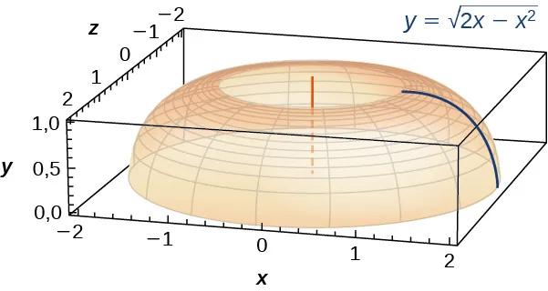
Generated surface: Partial toroidal surface, depending on the axis position and rotation angle.
Characteristics:
- The axis lies in the plane of the semicircular arc.
- The axis does not coincide with the diameter.
- The semicircular arc sweeps around the external axis.
- A full rotation produces a surface of revolution based on the semicircular profile.

Rotation About an Intersecting Axis
# Source: AI Source: Provided by: [Data Path: Persons Table -> ID Column: 1, Name_En Column: Motasem Essam] -> From: [ChatGPT] on [7/25/2026]
When the semicircular arc rotates around another axis in its plane that intersects the circular profile, it produces a surface of revolution whose shape depends on the axis position and the arc's orientation.
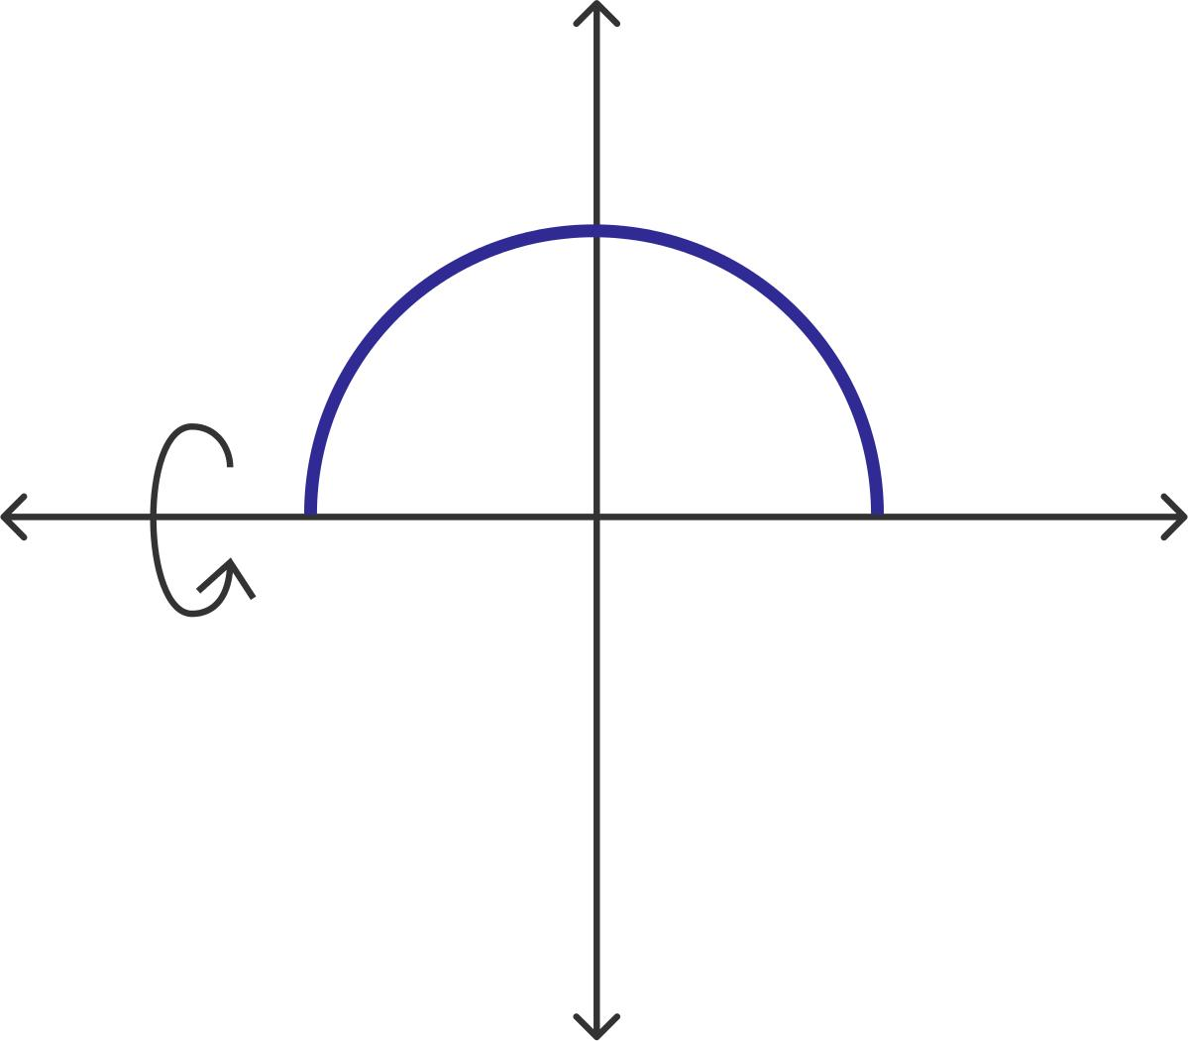
Characteristics:
- The axis intersects the circular profile.
- The axis is different from the diameter.
- Different points of the arc trace circular paths around the axis.
- The generated surface may contain spherical or toroidal portions, depending on the configuration.

Mathematical Representation
# Source: AI Source: Provided by: [Data Path: Persons Table -> ID Column: 1, Name_En Column: Motasem Essam] -> From: [ChatGPT] on [7/25/2026]
Consider a semicircular arc of radius $r$, centered at the origin, with its diameter along the $x$-axis.
Its parametric equation is:
$$x=rcost$$
$$y=rsint$$
where:
$$0≤t≤π$$
When the arc rotates around its diameter (the $x$-axis), its generated spherical surface can be represented by:
$$\boxed{beginalignedx\&=rcost\backslash y\&=rsintcosφ\backslash z\&=rsintsinφendaligned}$$
Where:
- $r$: Radius of the semicircle.
- $t$: Parameter along the semicircular arc.
- $φ$: Rotation angle around the diameter.
- $0≤t≤π$.
- $0≤φ<2π$.
The resulting equation is:
$$\boxed{x^{2}+y^{2}+z^{2}=r^{2}}$$
This is the equation of a sphere.

Generated Surfaces and Solids

Spherical Surface
# Source: AI Source: Provided by: [Data Path: Persons Table -> ID Column: 1, Name_En Column: Motasem Essam] -> From: [ChatGPT] on [7/25/2026]
The complete semicircular arc rotates around its diameter, generating the entire spherical surface.
Surface area:
$$\boxed{A=4πr^{2}}$$

Solid Sphere
# Source: AI Source: Provided by: [Data Path: Persons Table -> ID Column: 1, Name_En Column: Motasem Essam] -> From: [ChatGPT] on [7/25/2026]
When the filled semicircular region rotates around its diameter, it generates a solid sphere.
Volume:
$$\boxed{V=\frac{4}{3}πr^{3}}$$
Important distinction:
- Semicircular arc → Spherical surface.
- Semicircular region → Solid sphere.

Spherical Zone
# Source: AI Source: Provided by: [Data Path: Persons Table -> ID Column: 1, Name_En Column: Motasem Essam] -> From: [ChatGPT] on [7/25/2026]
A portion of a semicircular arc rotating around its diameter generates a Spherical Zone.
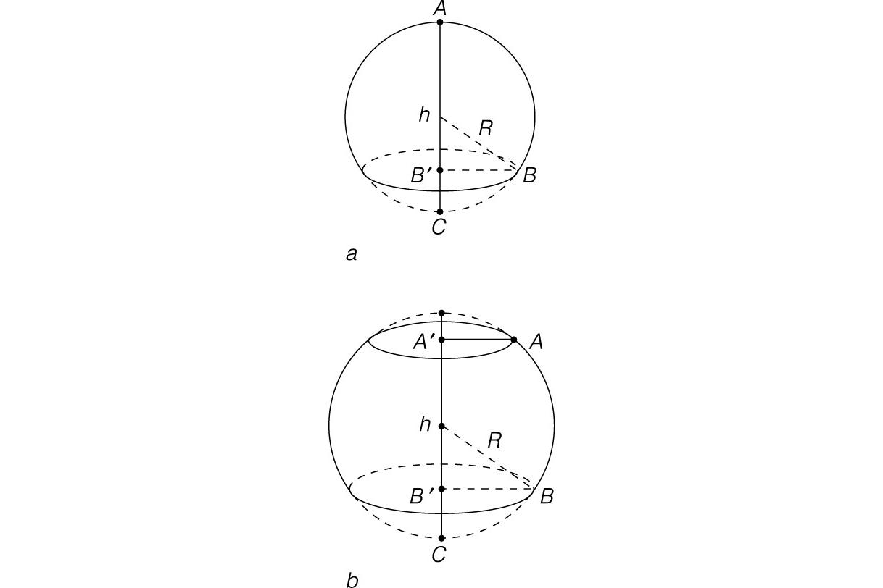
A spherical zone is a portion of a spherical surface bounded by two parallel circular planes.
Its surface area is:
$$\boxed{A=2πrh}$$
Where:
- $r$: Radius of the sphere.
- $h$: Height of the spherical zone.
A complete semicircular arc generates a complete sphere, which is the special case $h=2r$.

Geometric Measurements and Formulas
# Source: AI Source: Provided by: [Data Path: Persons Table -> ID Column: 1, Name_En Column: Motasem Essam] -> From: [ChatGPT] on [7/25/2026]
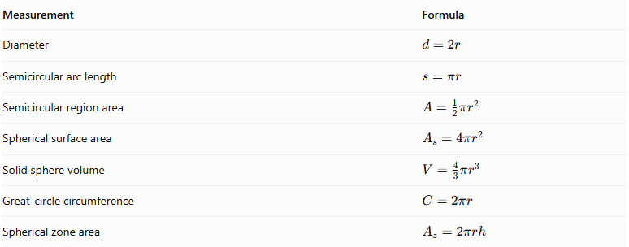
Measurement | Formula
Diameter | $$d=2r$$
Semicircular arc length | $$s=πr$$
Semicircular region area | $$A=\frac{1}{2}πr^{2}$$
Spherical surface area | $$A_{s}=4πr^{2}$$
Solid sphere volume | $$V=\frac{4}{3}πr^{3}$$
Great-circle circumference | $$C=2πr$$
Spherical zone area | $$A_{z}=2πrh$$

Mathematical Properties
# Source: AI Source: Provided by: [Data Path: Persons Table -> ID Column: 1, Name_En Column: Motasem Essam] -> From: [ChatGPT] on [7/25/2026]
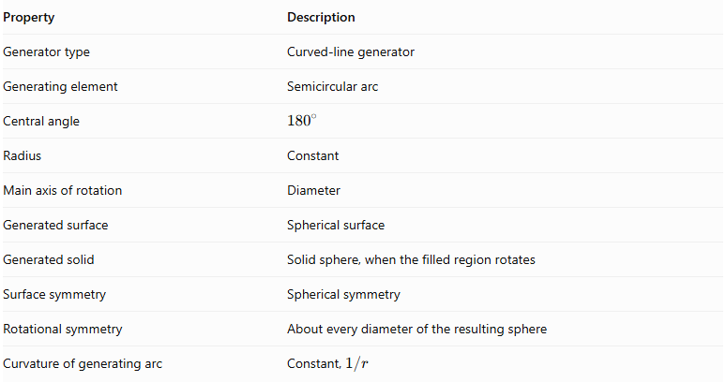
Property | Description
Generator type | Curved-line generator
Generating element | Semicircular arc
Central angle | $${180}^{∘}$$
Radius | Constant
Main axis of rotation | Diameter
Generated surface | Spherical surface
Generated solid | Solid sphere, when the filled region rotates
Surface symmetry | Spherical symmetry
Rotational symmetry | About every diameter of the resulting sphere
Curvature of generating arc | Constant, $1/r$

Comparison with Other Circular-Arc Generators
# Source: AI Source: Provided by: [Data Path: Persons Table -> ID Column: 1, Name_En Column: Motasem Essam] -> From: [ChatGPT] on [7/25/2026]
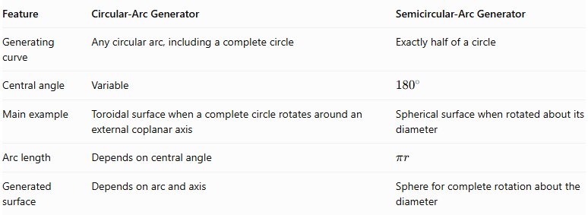
Feature | Circular-Arc Generator | Semicircular-Arc Generator
Generating curve | Any circular arc, including a complete circle | Exactly half of a circle
Central angle | Variable | $${180}^{∘}$$
Main example | Toroidal surface when a complete circle rotates around an external coplanar axis | Spherical surface when rotated about its diameter
Arc length | Depends on central angle | $$πr$$
Generated surface | Depends on arc and axis | Sphere for complete rotation about the diameter

Main Classification
# Source: AI Source: Provided by: [Data Path: Persons Table -> ID Column: 1, Name_En Column: Motasem Essam] -> From: [ChatGPT] on [7/25/2026]
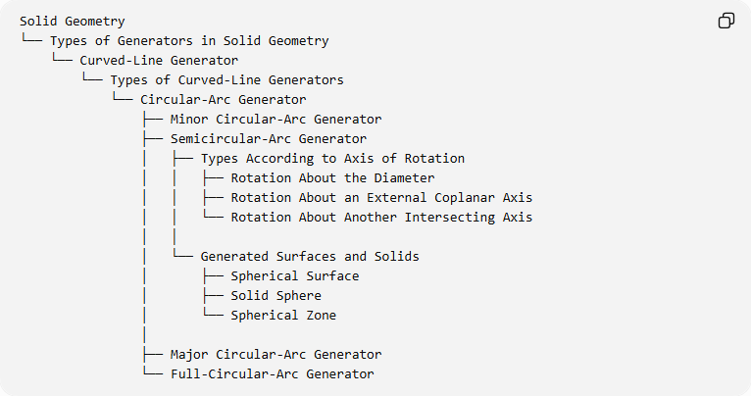
Solid Geometry
└── Types of Generators in Solid Geometry
└── Curved-Line Generator
└── Types of Curved-Line Generators
└── Circular-Arc Generator
├── Minor Circular-Arc Generator
├── Semicircular-Arc Generator
│ ├── Types According to Axis of Rotation
│ │ ├── Rotation About the Diameter
│ │ ├── Rotation About an External Coplanar Axis
│ │ └── Rotation About Another Intersecting Axis
│ │
│ └── Generated Surfaces and Solids
│ ├── Spherical Surface
│ ├── Solid Sphere
│ └── Spherical Zone
│
├── Major Circular-Arc Generator
└── Full-Circular-Arc Generator
Classification note: The three axis arrangements are geometric configurations, not three universally standardized types of semicircular generators. Rotation about the diameter is the principal configuration for generating a sphere. Rotation about an external coplanar axis produces only the corresponding portion of a toroidal surface when a semicircular profile is used.

Key Points
# Source: AI Source: Provided by: [Data Path: Persons Table -> ID Column: 1, Name_En Column: Motasem Essam] -> From: [ChatGPT] on [7/25/2026]
- A semicircular-arc generator uses exactly half of a circle.
- Its central angle is ${180}^{∘}$.
- Its arc length equals $πr$.
- Rotating the semicircular arc about its diameter generates a spherical surface.
- Rotating the filled semicircular region about its diameter generates a solid sphere.
- Rotating only part of the semicircular arc about its diameter generates a spherical zone.
- The radius of the generated sphere is equal to the radius of the original semicircle.

Conclusion
# Source: AI Source: Provided by: [Data Path: Persons Table -> ID Column: 1, Name_En Column: Motasem Essam] -> From: [ChatGPT] on [7/25/2026]
The Semicircular-Arc Generator is a specialized form of the Circular-Arc Generator. Its principal application is the generation of spherical geometry by rotating a semicircular arc around its diameter.
It provides the geometric generating principle behind the spherical surface, solid sphere, and spherical zones.

